CSAY OBSTACLE HEIGHT CALCULATION

*(A Free Open-Source Software)*

Based

on

OBSTACLE LIMITATION SURFACE

(ICAO ANNEX – 14 VOL – I, 9th EDITION)

AJAY YADAV

2023

Table of Content

CHAPTER 1 DEFINITION 1

1.1 Definitions as per ICAO Annex 14 1

1.1.1 Aerodrome 1

1.1.2 Balked Landing 1

1.1.3 Aerodrome Reference point 1

1.1.4 Clearway 1

1.1.5 Displaced Threshold 1

1.1.6 Obstacle 1

1.1.7 Obstacle Free Zone (OFZ) 2

1.1.8 Obstacle Limitation Surface (OLS) 2

1.1.9 Runway 2

1.1.10 Runway strips 2

1.1.11 Threshold 2

CHAPTER 2 OBSTACLE LIMITATION SURFACE 3

2.1 Types of Obstacle Limitation Surfaces 3

2.2 OLS requirement 3

2.3 Details of each OLS 4

2.3.1 Conical Surface 4

2.3.2 Inner Horizontal Surface 4

2.3.3 Inner Approach Surface 5

2.3.4 Approach Surface 5

2.3.5 Transitional Surface 6

2.3.6 Inner Transitional Surface 6

2.3.7 Balked Landing Surface 8

2.3.8 Take Off Climb Surface 8

2.3.9 Outer Horizontal Surface 9

# DEFINITION

## Definitions as per ICAO Annex 14

### Aerodrome

A defined area on land or water (including any buildings, installations and equipment) intended to be used either wholly or in part for the arrival, departure and surface movement of aircraft.

### Balked Landing

A landing manoeuvre that is unexpectedly discontinued at any point below the obstacle clearance altitude/height (OCA/H).

### Aerodrome Reference point

The designated geographical location of an aerodrome

### Clearway

A defined rectangular area on the ground or water under the control of the appropriate authority, selected or prepared as a suitable area over which an aeroplane may make a portion of its initial climb to a specified height.

### Displaced Threshold

A threshold not located at the extremity of a runway

### Obstacle

All fixed (whether temporary or permanent) and mobile objects, or parts thereof, that:

a) are located on an area intended for the surface movement of aircraft; or

b) extend above a defined surface intended to protect aircraft in flight; or

c) stand outside those defined surfaces and that have been assessed as being a hazard to air navigation.

### Obstacle Free Zone (OFZ)

The airspace above the inner approach surface, inner transitional surfaces, and balked landing surface and that portion of the strip bounded by these surfaces, which is not penetrated by any fixed obstacle other than a low-mass and frangibly mounted one required for air navigation purposes.

### Obstacle Limitation Surface (OLS)

It defines the limit to which objects may project into the airspace

### Runway

A defined rectangular area on a land aerodrome prepared for the landing and take-off of aircraft.

### Runway strips

A defined area including the runway and stopway, if provided, intended:

a) to reduce the risk of damage to aircraft running off a runway; and

b) to protect aircraft flying over it during take-off or landing operations.

### Threshold

The beginning of that portion of the runway usable for landing.

# OBSTACLE LIMITATION SURFACE

## Types of Obstacle Limitation Surfaces

1. CONICAL SURFACE
2. INNER HORIZONTAL SURFACE
3. INNER APPROACH SURFACE
4. APPROACH SURFACE
5. TRANSITIONAL SURFACE
6. INNER TRANSITIONAL SURFACE
7. BALKED LANDING SURFACE
8. TAKEOFF CLIMB SURFACE
9. OUTER HORIZONTAL SURFACE

## OLS requirement

|  |  |  |
| --- | --- | --- |
| Runway Category | Runway Sub-Category | Obstacle Limitation surface |
| Non-Instrument Runway |  | 1. Conical surface 2. Inner Horizontal 3. Approach surface 4. Transitional surface |
| Instrument Runway | Non-Precision Approach Runway | 1. Conical surface 2. Inner Horizontal 3. Approach surface 4. Transitional surface |
| Precision Approach Runway Category I | Mandatory Surfaces (Shall be)   1. Conical surface 2. Inner Horizontal 3. Approach surface 4. Transitional surface   *Optional Surfaces (Should be)*   1. *Inner Approach surface* 2. *Inner Transitional surface* 3. *Balked landing surface* |
| Precision Approach Runway Category II or III | 1. Conical surface 2. Inner Horizontal 3. Approach surface 4. Transitional surface 5. Inner Approach surface 6. Inner Transitional surface 7. Balked landing surface |

* Note – 1: Take off climb surface shall be established for all runways meant of Take off climb.

## Details of each OLS

In this document, calculations and drawings shall be based on “**PRECISION APPROACH RUNWAY CAT II OR III**” based on Table 4-1 Dimensions and slopes of obstacle limitation surfaces — Approach runways of ICAO ANNEX – 14, Vol – I, 9th Edition.

### Conical Surface

|  |  |
| --- | --- |
| Surfaces | Dimension |
| CONICAL |  |
| Slope_% | 5 |
| Height_m | 100 |

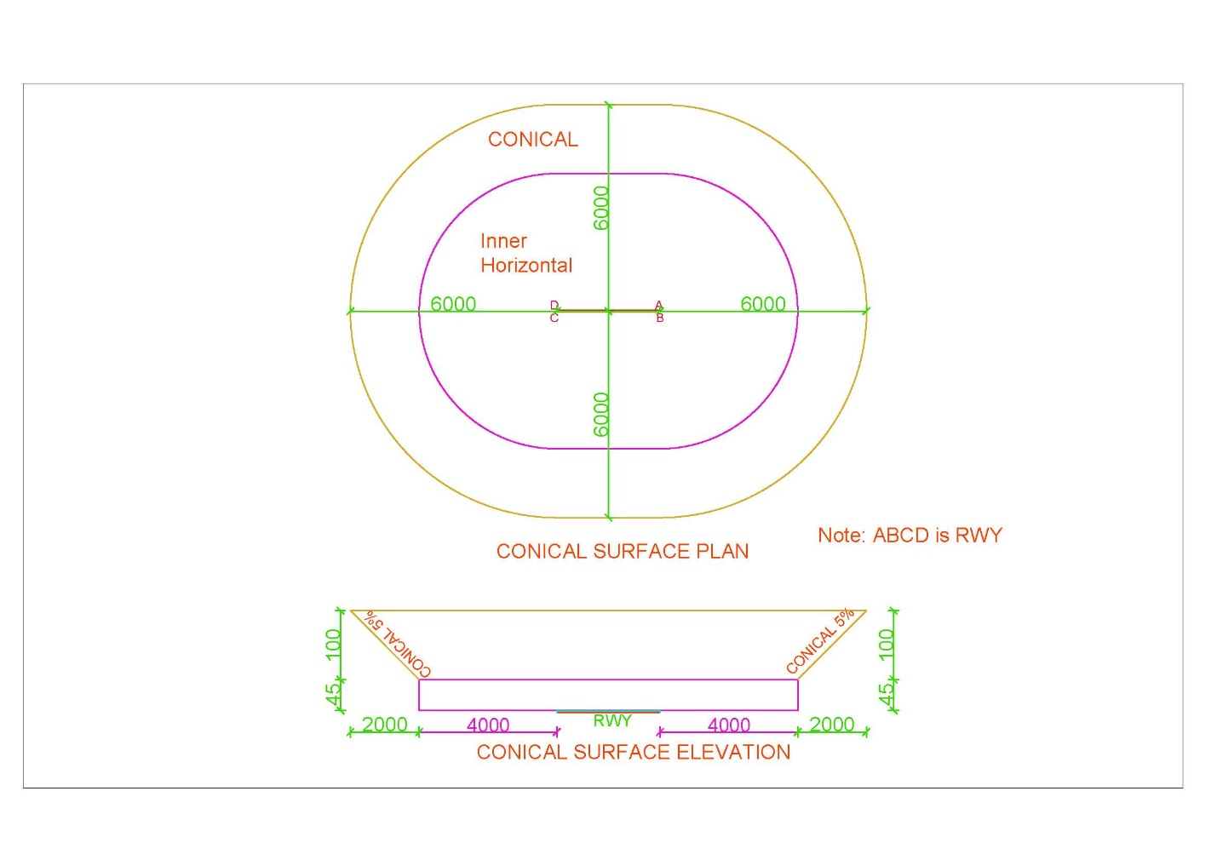

### Inner Horizontal Surface

|  |  |
| --- | --- |
| Surfaces | Dimension |
| INNER_HORIZONTAL |  |
| Height_m | 45 |
| Radius_m | 4000 |

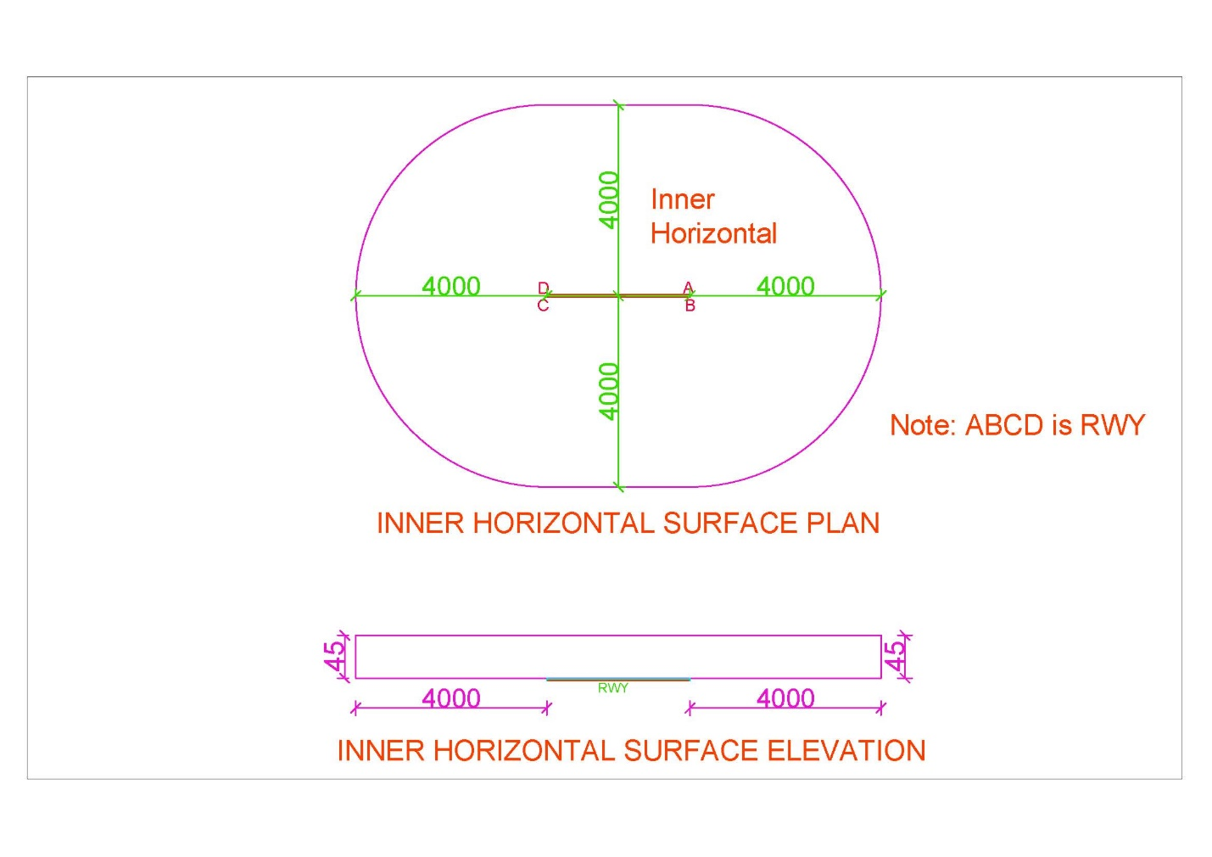

### Inner Approach Surface

|  |  |
| --- | --- |
| Surfaces | Dimension |
| INNER_APPROACH |  |
| Width_m | 120 |
| Distance_from_threshold_m | 60 |
| Length_m | 900 |
| Slope_% | 2 |

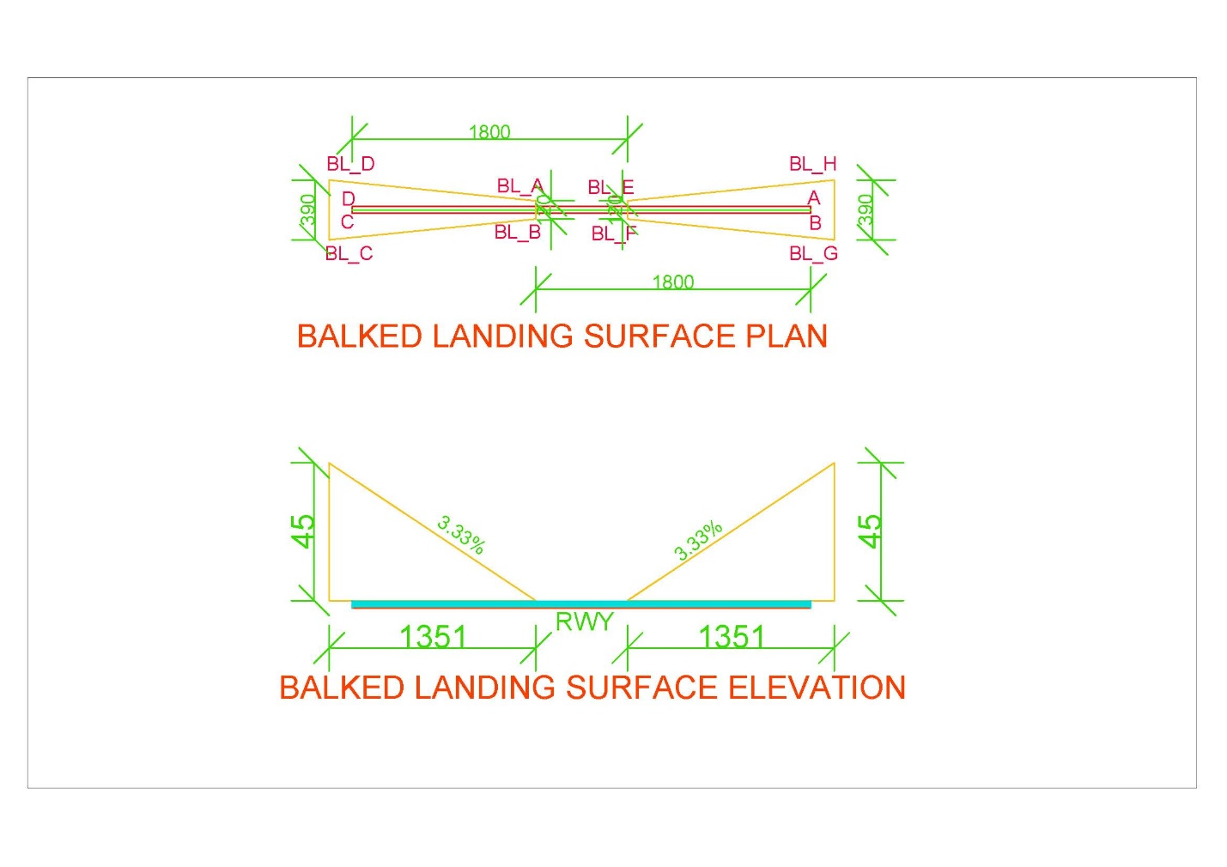

### Approach Surface

|  |  |  |  |
| --- | --- | --- | --- |
| Surfaces | Dimension | Surfaces | Dimension |
| Length_of_inner_edge_m | 280 | Second_Section |  |
| Distance_from_threshold_m | 60 | Length_m | 3600 |
| Divergence_% | 15 | Slope_% | 2.5 |
| First_Section |  | Horizontal_Section |  |
| Length_m | 3000 | Length_m | 8400 |
| Slope_% | 2 |  |  |

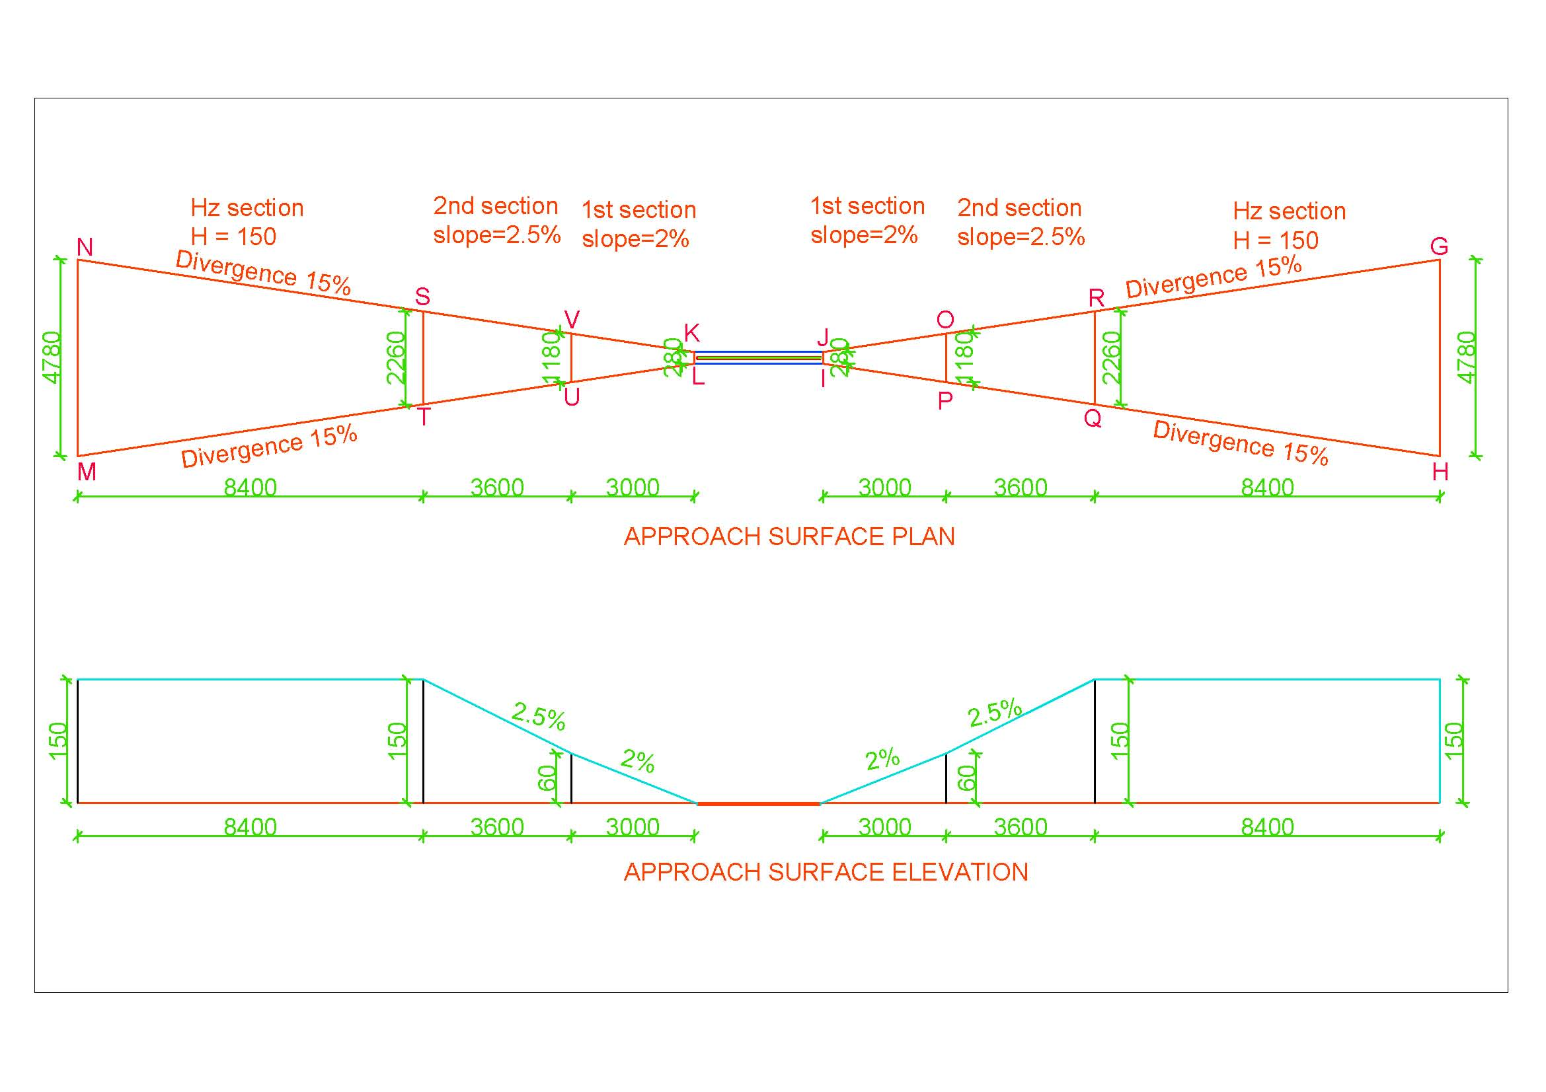

### Transitional Surface

|  |  |
| --- | --- |
| Surfaces | Dimension |
| INNER_TRANSITIONAL |  |
| Slope_% | 14.3 |

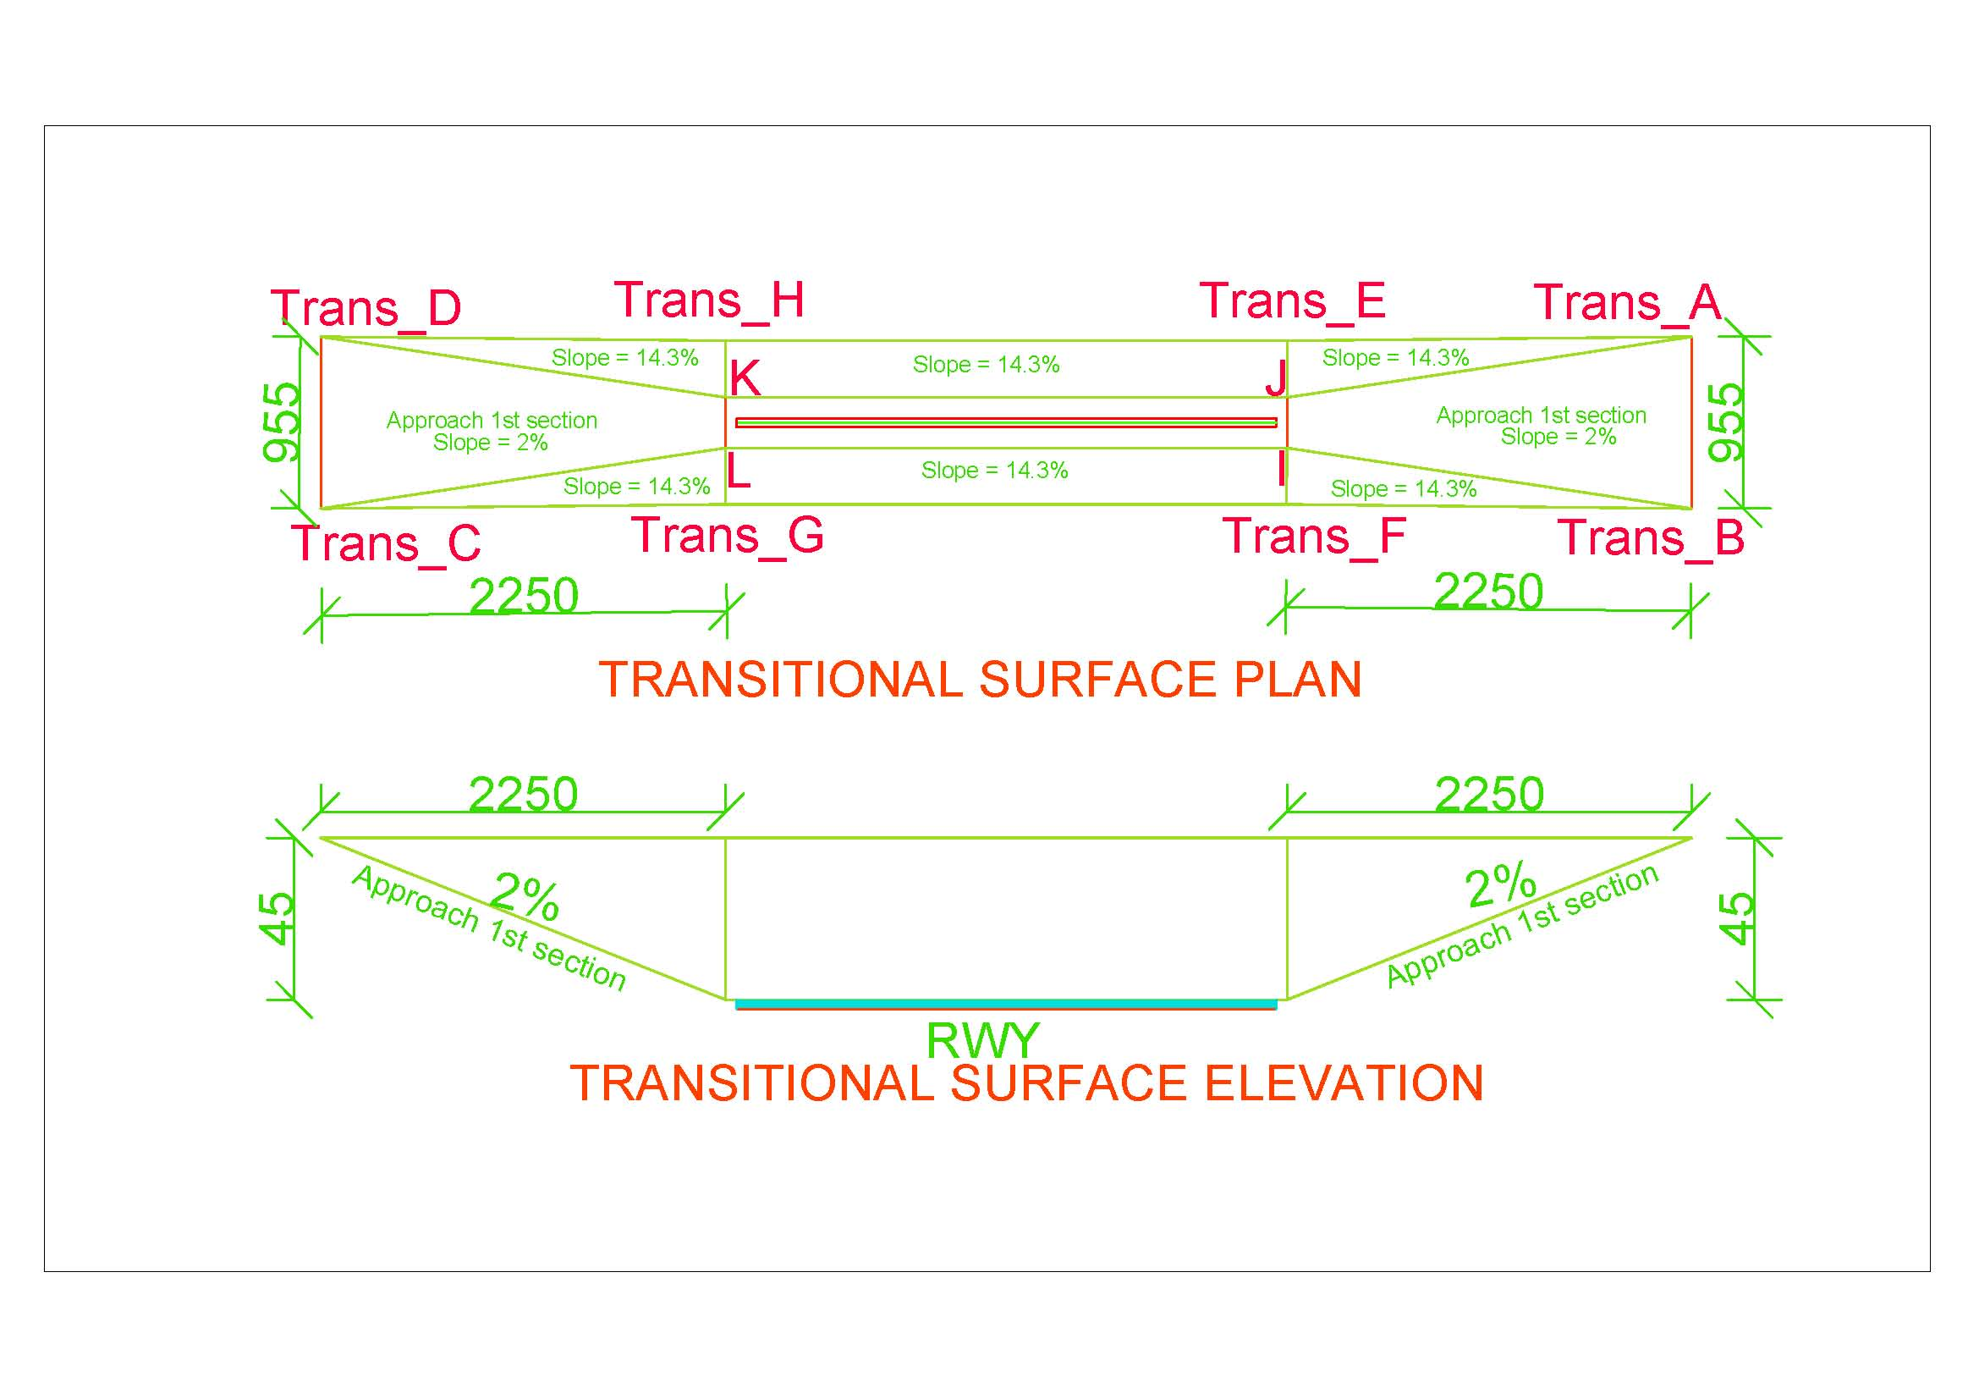

### Inner Transitional Surface

|  |  |
| --- | --- |
| Surfaces | Dimension |
| TRANSITIONAL |  |
| Slope_% | 33.3 |

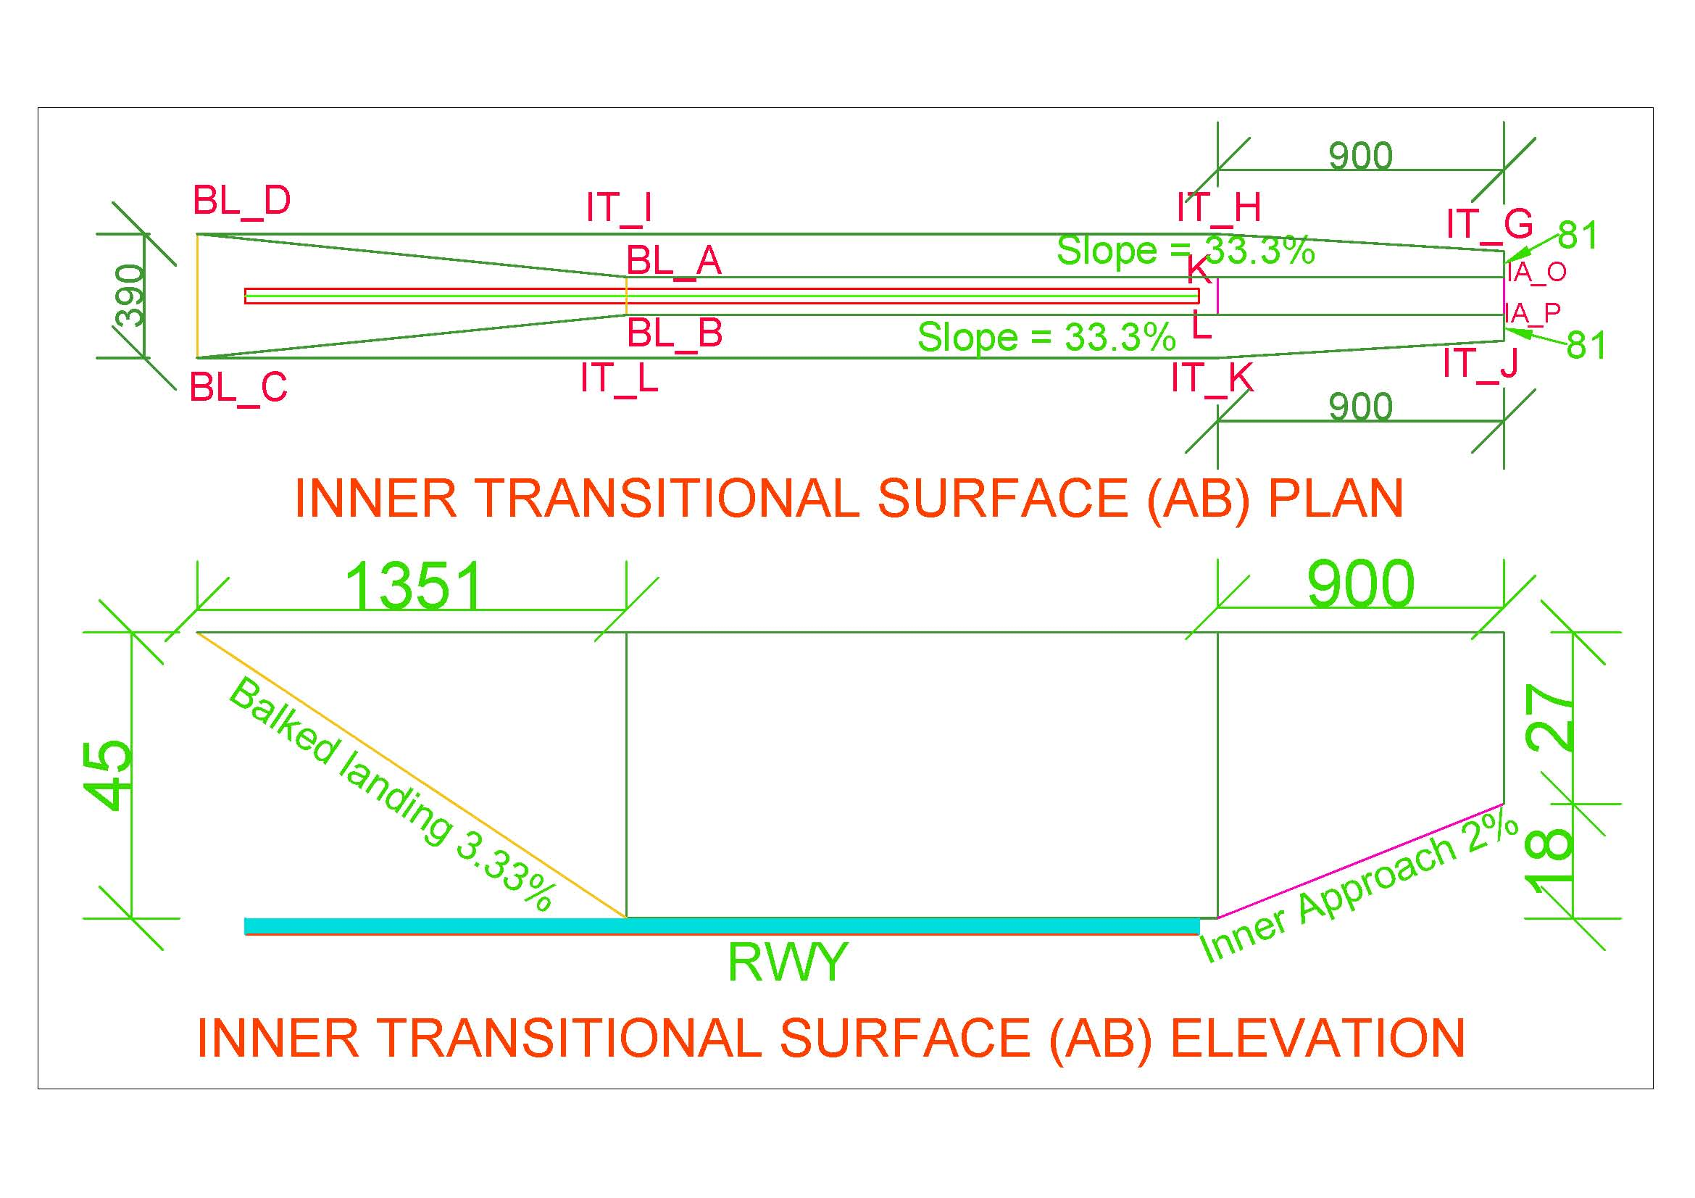

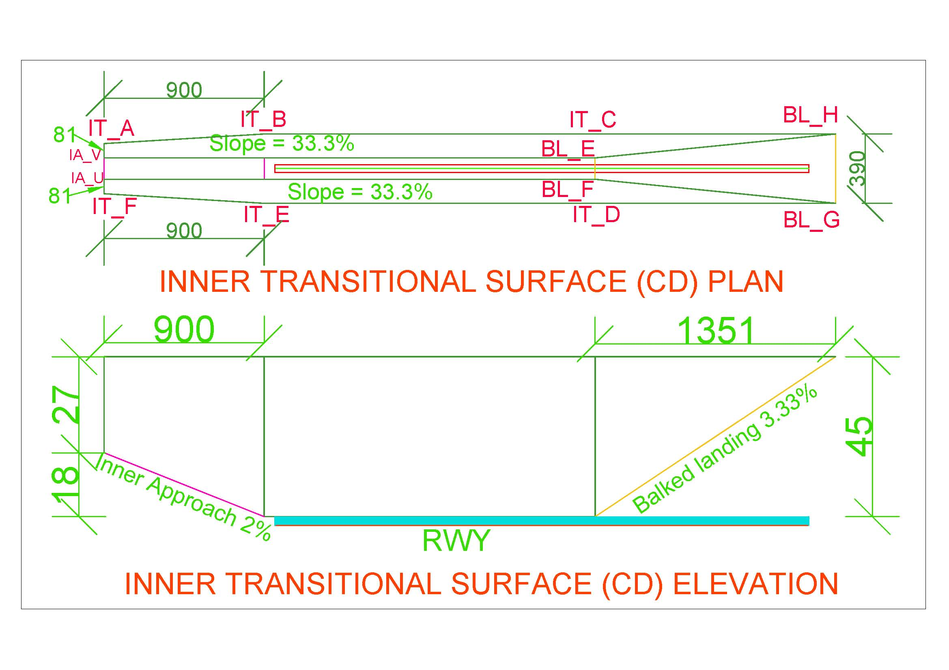

### Balked Landing Surface

|  |  |
| --- | --- |
| Surfaces | Dimension |
| BALKED_LANDING |  |
| Length_of_inner_edge_m | 120 |
| Distance_from_threshold_m | 1800 |
| Divergence_% | 10 |
| Slope_% | 3.33 |



### Take Off Climb Surface

|  |  |
| --- | --- |
| Surfaces | Dimension |
| TAKE_OF_CLIMB_SURFACE |  |
| Length_of_inner_edge_m | 180 |
| Distance_from_RWY_End_m | 60 |
| Divergence_% | 12.5 |
| Final_Width_m | 1800 |
| Length_m | 15000 |
| Slope_% | 2 |

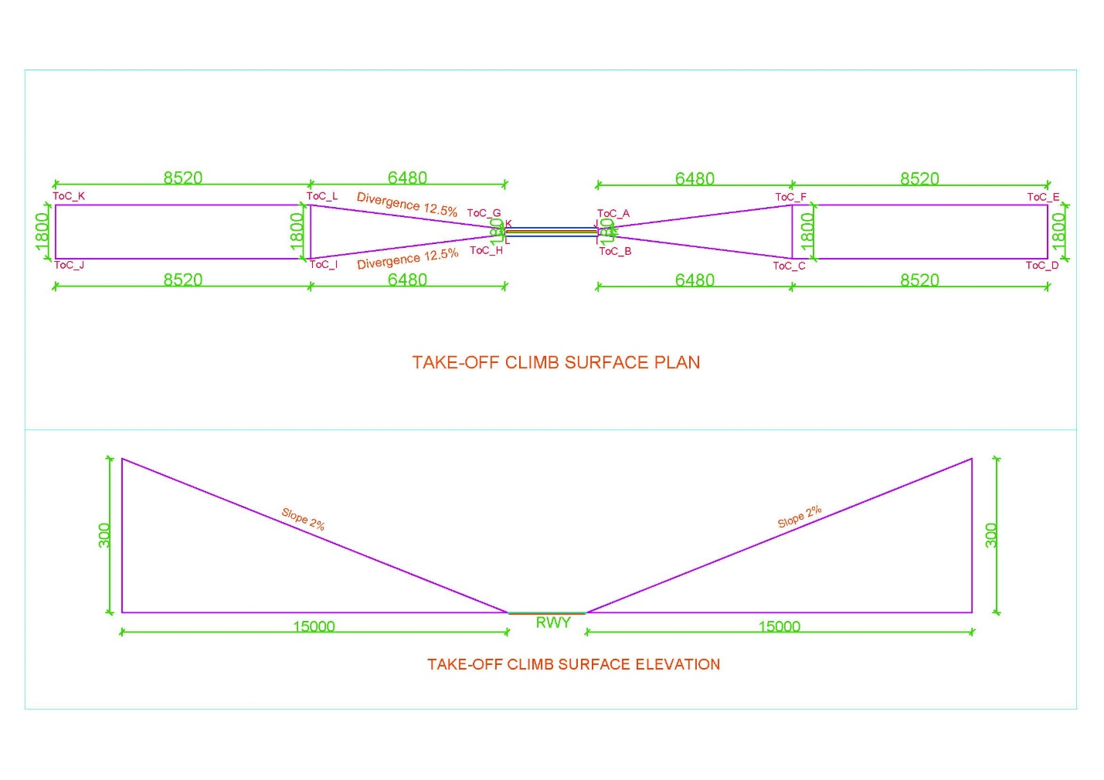

### Outer Horizontal Surface

|  |  |
| --- | --- |
| Surfaces | Dimension |
| Center at | ARP |
| Radius_m | 15000 |

